How to create and use Google Earth Maps from a NYSEG/RGE Pole Application

- Once the application has been filled out as instructed; go to the tab in Excel labeled page 1
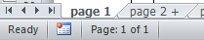
- Go to the top of the page and locate the button called “Generate Google Earth Map File” which is just above the Facility Section and click the button
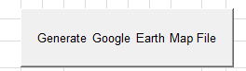
- The code will run for about 30-45 seconds to create the map file and a message box will be displayed indicating how many items were created and the location the file was saved to
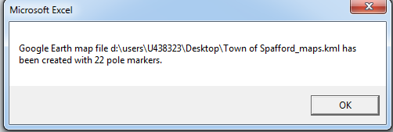
- Now, you will need Google Earth installed to use the map. Once it is installed, open Google Earth

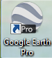
- Next, go to File and select Open...
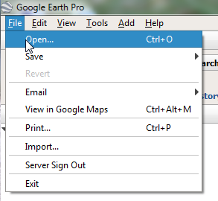
- Locate the saved file(s). Please note: There will be one .kml file for every page of the pole application. Select it and then select open at the bottom of the dialog box
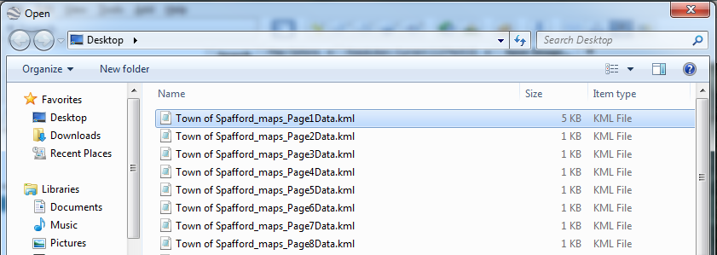

- Now, the map will load all of the points from the Pole Application. The points are labeled with the Application Item number
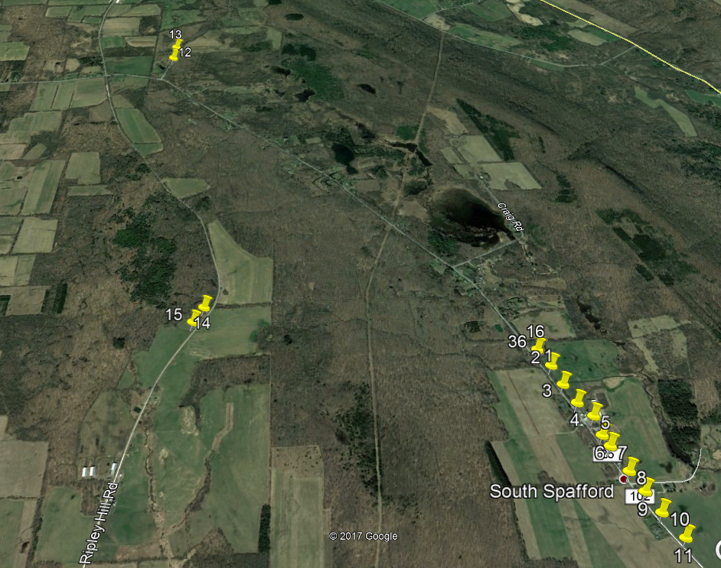

- You can get more information about each pole by clicking on the marker
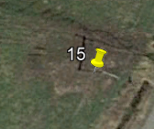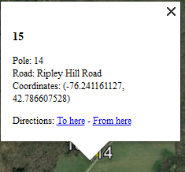
- Now you will need to save the map file to attach to your application via Google Earth by clicking on the image icon
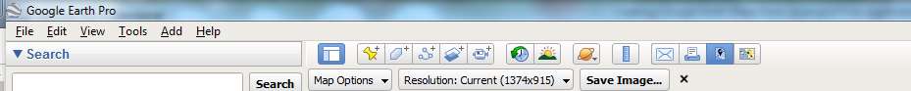

- Update the map file legend and title as you see fit and press Save Image
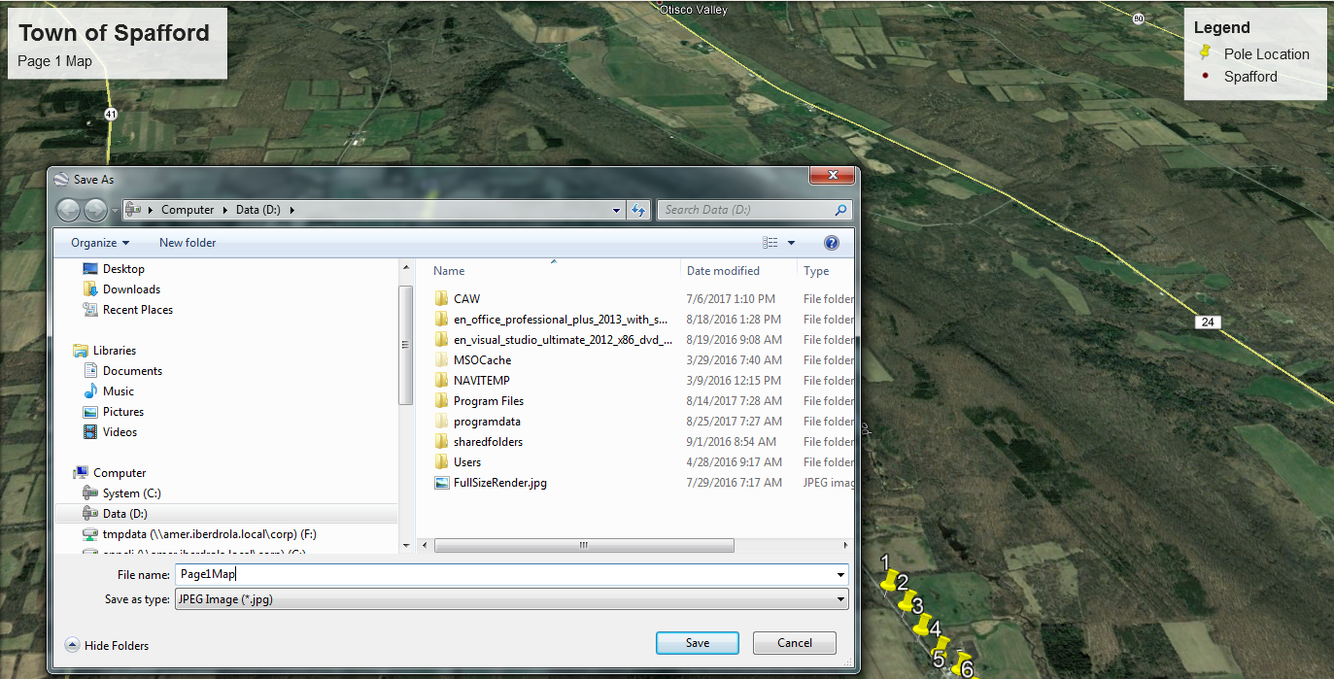
- Save the .jpg or .pdf file and then attach it to your email application response. You should attach one map file with every map image.

